Manuscript Preparation Guidelines for Computer Science Journals

Author Name1 email@address.com
Faculty/Department/Division
University
City, Post code, Country

Author Name2 email@address.com
Faculty/Department/Division
University
City, Post code, Country

Abstract

These are the manuscript preparation guidelines used as a standard template. Author must follow these instructions and ensure that the manuscript is carefully aligned with these guidelines including headings, figures, tables and references. Manuscripts with poor or no typesetting are not preliminary approved and consider for review.

Keywords: Keyword1, Keyword2, Keyword3, Keyword4, Keyword5.

INTRODUCTION
These are the manuscript preparation guidelines used as a standard template. Author must follow these instructions and ensure that the manuscript is carefully aligned with these guidelines including headings, figures, tables and references. Manuscripts with poor or no typesetting are not preliminary approved and consider for review.

LITERATURE REVIEW
These are the manuscript preparation guidelines used as a standard template. Author must follow these instructions and ensure that the manuscript is carefully aligned with these guidelines including headings, figures, tables and references. Manuscripts with poor or no typesetting are not preliminary approved and consider for review.

History and Background
These are the manuscript preparation guidelines used as a standard template. Author must follow these instructions and ensure that the manuscript is carefully aligned with these guidelines including headings, figures, tables and references. Manuscripts with poor or no typesetting are not preliminary approved and consider for review.

  - Further Details
These are the manuscript preparation guidelines used as a standard template. Author must follow these instructions and ensure that the manuscript is carefully aligned with these guidelines including headings, figures, tables and references. Manuscripts with poor or no typesetting are not preliminary approved and consider for review.

These are the manuscript preparation guidelines used as a standard template. Author must follow these instructions and ensure that the manuscript is carefully aligned with these guidelines including headings, figures, tables and references. Manuscripts with poor or no typesetting are not preliminary approved and consider for review.
These are the manuscript preparation guidelines used as a standard template. Author must follow these instructions and ensure that the manuscript is carefully aligned with these guidelines including headings, figures, tables and references. Manuscripts with poor or no typesetting are not preliminary approved and consider for review.

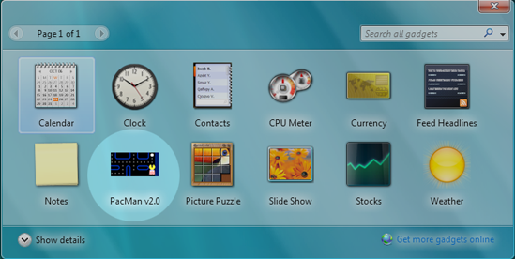

FIGURE 1: All figures must be aligned centered.

These are the manuscript preparation guidelines used as a standard template. Author must follow these instructions and ensure that the manuscript is carefully aligned with these guidelines including headings, figures, tables and references. Manuscripts with poor or no typesetting are not preliminary approved and consider for review.
Column1 | Column2 | Column3
Value 1 | Value 2 | Value 3
Value 4 | Value 5 | Value 6
Value 7 | Value 8 | Value 9

TABLE 1: All tables must be aligned centered.

This guideline is used for all journals. These are the manuscript preparation guidelines used as a standard template for all journal submissions. Author must follow these instructions while preparing/modifying these guidelines.

REFERENCES
The references should be arranged in alphabetical order without numbers/bullets and should have either parenthetical or narrative citation within the paper.

Example

Grady, J. S., Her, M., Moreno, G., Perez, C., & Yelinek, J. (2019). Emotions in storybooks: A comparison of storybooks that represent ethnic and racial groups in the United States. Psychology of Popular Media Culture, 8(3), 207–217. https://doi.org/10.1037/ppm0000185.

* Parenthetical citation: (Grady et al., 2019)
* Narrative citation: Grady et al. (2019)

For complete reference examples for journal articles, conference proceedings, books and others, please refer to APA Styling Guidelines.

APA Reference Style - https://apastyle.apa.org/style-grammar-guidelines/references/examples

